**CRUD I: FINDING DOCUMENTS**

**Browsing and Selecting Collections**

MongoDB is one of the easiest databases to get started with! MongoDB can easily be run in a terminal using the [MongoDB Shell](https://www.mongodb.com/docs/mongodb-shell/?utm_campaign=academia_partners&utm_source=codecademy&utm_medium=referral) (mongosh for short). Throughout this course, we will be providing you with your very own mongosh shell via a terminal. Now - before we can get into making fancy queries on our data, one of the first things we will have to do is navigate around our database instances. MongoDB allows us to store multiple databases inside of a single running instance.

For example, imagine we are a freelance developer using MongoDB to manage the data for multiple different projects: an e-commerce shop, a social media application, and a portfolio website. To compartmentalize our data, we can create a separate database for each project.

With all these databases in our MongoDB instance, how exactly would we choose and navigate around them? Fortunately, MongoDB offers us some handy commands to easily see a list of all our databases, switch databases, and confirm which database we are currently using.

First, let’s list all of our existing databases for our freelance projects. To see all of our databases, we can run the command show dbs. This will output a list of all the databases in our current instance and the disk space each takes up. Here is what it might look like:

online_plant_shop       73.7 KiB  
plant_lovers_meet       55.7 MiB  
my_portfolio_site       9.57 MiB  
admin                    340 KiB  
local                   1.37 GiB  
config                 12.00 KiB

Looking at the example output above, notice three unique databases: admin, [config](https://www.mongodb.com/docs/manual/reference/config-database/?utm_campaign=academia_partners&utm_source=codecademy&utm_medium=referral), and [local](https://www.mongodb.com/docs/manual/reference/local-database/?utm_campaign=academia_partners&utm_source=codecademy&utm_medium=referral). These databases are included by MongoDB to help configure our instance. In addition, we have our three databases for each of our freelance projects.

*Note: We won’t be working with the admin, config, and local databases throughout this course, but feel free to explore them on your own!*

Now that we have a full list of our databases in our MongoDB instance, we will need to choose the specific one we want to work with. To navigate to a particular database, we can run the use <db> command. For example, if we wanted to use our e-commerce database, we’d run use online_plant_shop. This would place us inside our online_plant_shop database, where we have the option to view and manage all of its collections. It’s important to note, that if the database we specify does not exist, MongoDB will create it, and place us inside of that database.

Here is what our terminal might look like:

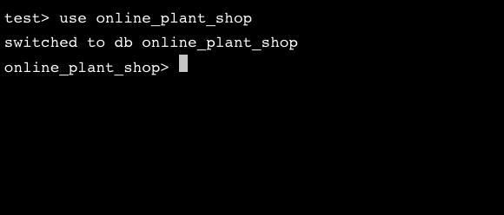

Notice that the terminal will list the current database we are in before a > symbol. When we switch databases, we should see the name of the database we switched into displayed there instead. In this case, we can see the prompt changed from test> to online_plant_shop>.

If at any point we lose track of what database we are in, we can orient ourselves by running the command, db. This will output the name of the database we are currently using. It would look like this:

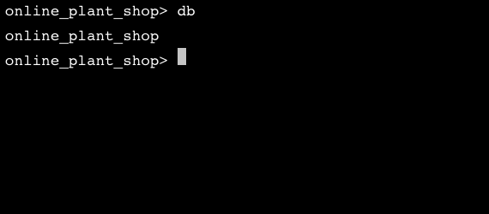

Now that we have covered the basics, let’s practice navigating a MongoDB instance!

**Instructions**

**1.**

Let’s get familiar with our environment and orient ourselves by seeing what databases currently exist in our database instance.

Use the appropriate MongoDB command to see a list of all the current databases.

To check your commands for each task, use the **Check Work** button.

*Note: Every exercise in this course will have the MongoDB Shell connected to a test database when it first loads.*

Checkpoint 2 Passed

Hint

You can use the show dbs command to see a list of all your databases.

**2.**

Throughout this course, we will be working closely with the restaurants database. Navigate to the restaurants database in your MongoDB Shell.

Checkpoint 3 Passed

Hint

You can use the use <db> command to navigate to a specific database.

**3.**

Before moving on, use the appropriate MongoDB command to confirm that you are in the restaurants database.

Checkpoint 4 Passed

Hint

You can use the db command to see which database you are actively using. The output should return restaurants.

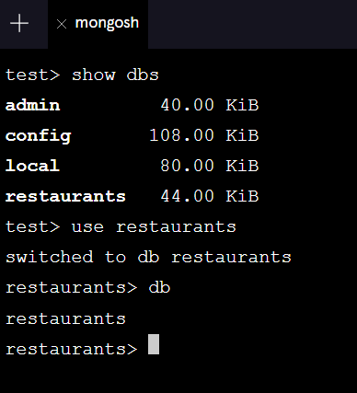

**Introduction to Querying**

In the world of databases, [persistence](https://en.wikipedia.org/wiki/Persistent_data) describes a database’s ability to store data that is stable and enduring. There are four essential functions that a persistent database must be able to perform: create new data entries, and read, update and delete existing entries. We can summarize these four operations with the acronym CRUD.

In this lesson, we’ll focus on the R in CRUD, reading data. So - how exactly do we start to read data from our MongoDB database? Well, in order to read data, we must first **query** the database. Querying is the process by which we request data from the database. The most common way to query data in MongoDB is to use the [.find()](https://www.mongodb.com/docs/manual/reference/method/db.collection.find/?utm_campaign=academia_partners&utm_source=codecademy&utm_medium=referral) method. Let’s take a look at the syntax:

db.<collection>.find()

Notice the .find() method must be called on a specific collection. When we call .find() without arguments, it will match all of the documents in the specified collection. If our query is successful, MongoDB will return a [**cursor**](https://www.mongodb.com/docs/v5.3/tutorial/iterate-a-cursor/), an object that points to the documents matched by our query. Because our queries could potentially match large numbers of documents, MongoDB uses cursors to return our results in batches.

In other words, when we query collections using the .find() method, MongoDB will return up to the first set of matching documents. If we want to see the next batch of documents, we use the it keyword (short for iterate).

Now, let’s practice using the .find() method!

### Instructions

**1.**

Inside the restaurants database, there is a collection called listingsAndReviews.

Connect to the restaurants database, and then query the listingsAndReviews collection to get familiar with the documents it stores.

After running the command, be sure to hit the **Check Work** button!

Checkpoint 2 Passed

Hint

Remember, you can query a collection using the following syntax:

db.<collection>.find();

To see a list of all collections in a database, you can type the command show collections.

Need another hint?

Your query should look as follows:

db.listingsAndReviews.find()

**2.**

The cursor only returned the first batch of documents. Iterate through the cursor to see the next batch of documents.

Checkpoint 3 Passed

Hint

You can use the it command to iterate through your cursor.

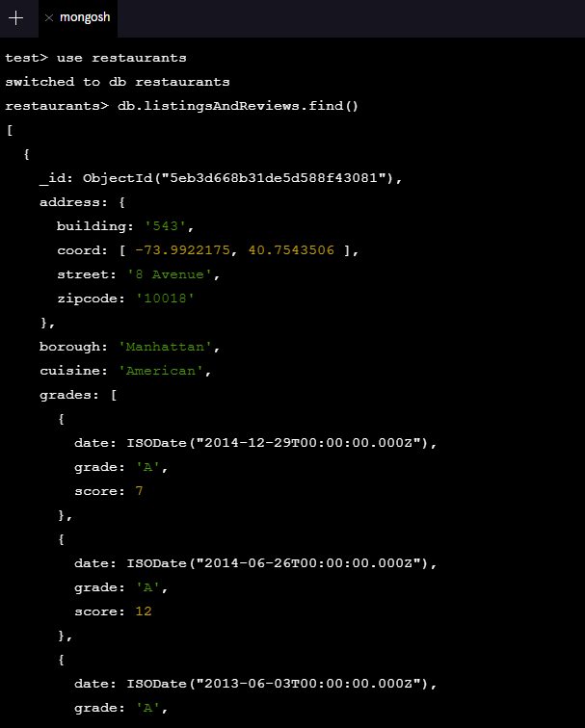

**Querying Collections**

In the last exercise, we learned how to use MongoDB’s .find() command to query all documents in a collection. However, what if we wanted to find a specific set of data in our collection? If we are looking for a specific document or set of documents, we can pass a query to the .find() method as its first argument (inside of the parenthesis ( )). With the query argument, we can list selection criteria, and only return documents in the collection that match those specifications.

The query argument is formatted as a document with field-value pairs that we want to match. Have a look at the example syntax below:

db.<collection>.find(  
  {  
    <field>: <value>,  
    <second_field>: <value>  
    ...  
  }  
);

We can have as many field-value pairs as we want in our query! To see the query in action, consider the following collection (shortened for brevity) of automobile makers in a collection named auto_makers:

{  
  maker: "Honda",  
  country: "Japan",  
  models: [  
    { name: "Accord" },  
    { name: "Civic" },  
    { name: "Pilot },  
    …  
  ]  
},  
   
{  
  maker: "Toyota",  
  country: "Japan",  
  models: [  
    { name: "4Runner" },  
    { name: "Corolla" },  
    { name: "Rav4" },  
    …  
  ]  
},  
{  
  maker: "Ford",  
  country: "USA",  
  models: [  
    { name: "F-150" },  
    { name: "Bronco"},  
    { name: "Escape"},  
    …  
  ]  
}

Imagine we wanted to query this collection to find all of the vehicles that are manufactured in "Japan". We could use the .find() command with a query, like so:

db.auto_makers.find({ country: "Japan" });

This would output the following documents from our collection:

{  
  maker: "Honda",  
  country: "Japan",  
  models: [  
    { name: "Accord" },  
    { name: "Civic" },  
    { name: "Pilot },  
    …  
  ]  
},  
{  
  maker: "Toyota",  
  country: "Japan",  
  models: [  
    { name: "4Runner" },  
    { name: "Corolla" },  
    { name: "Rav4" },  
    …  
  ]  
}

*Note: Query fields and their associated values are case and space sensitive. So, a query for a value "Corolla" would not be valid for a lowercase version like "corolla". This also applies if we accidentally included spaces. So, " corolla" would also not be valid if the value was "corolla".*

Under the hood, find() is actually using an **operator** to find matches to our query. Operators are special syntax that specifies some logical action we want to perform when our method executes. In the case of the .find() method, it uses the implicit equality operator, [$eq](https://www.mongodb.com/docs/manual/reference/operator/query/eq/?utm_campaign=academia_partners&utm_source=codecademy&utm_medium=referral), to match documents that include the specified field and value.

If we wanted to explicitly include the equality operator in our query document, we could do so with the following field-value pair:

{  
  <field>: { $eq: <value> }  
}

This is the equivalent of using the format seen in the first example:

{   
  <field>: <value>   
}

Fortunately, MongoDB handles implicit equality for us, so we can simply use the shorthand syntax for basic queries. In the upcoming exercises, we’ll learn about other operators that we can use to specify ranges and other criteria for matching documents in our queries.

Let’s practice using .find() to do some basic querying on our restaurants database!

**Instructions**

**1.**

You’re visiting Brooklyn, New York, and want to find a place for lunch. Thankfully, we have a database full of restaurants!

Connect to the restaurants collection, and then query the listingsAndReviews collection to find a list of restaurants in the borough "Brooklyn".

Press the **Check Work** button to move on to the next task.

Checkpoint 2 Passed

Hint

You can use the .find() method with the query {borough: "Brooklyn"} to find a list of Brooklyn restaurants.

Wow! There are so many options! Narrow down your results by querying the listingsAndReviews collection again, this time where the borough is "Brooklyn" and cuisine is "Caribbean".

Press the **Check Work** button again to complete the instructions for this exercise.

Checkpoint 3 Passed

Hint

You can use the .find() method with the filter {borough: "Brooklyn", cuisine: "Caribbean"} to find a list of Caribbean restaurants in Brooklyn.

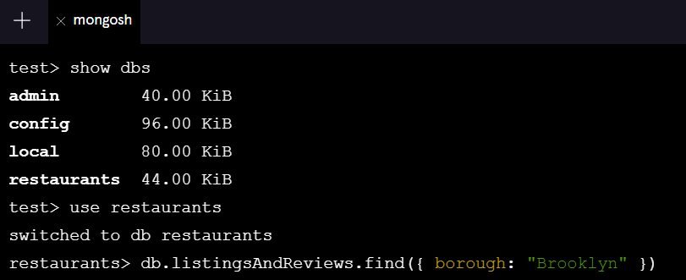

**Querying Embedded Documents**

When we are working with MongoDB databases, sometimes we’ll want to draw connections between multiple documents. MongoDB lets us embed documents directly within a parent document. These nested documents are known as **sub-documents**, and help us establish relationships between our data. For example, take a look at a single record from our auto_makers collection:

{  
  maker: "Honda",  
  country: "Japan",  
  models: [  
    { name: "Accord" },  
    { name: "Civic" },  
    { name: "Pilot" },  
    …  
  ]  
},  
…

Notice how inside of this document, we have a field named models that nests data about a maker’s specific model names. Here, we are establishing that the car maker "Honda" has multiple models that are associated with it. We will touch on building relationships in our database a bit later in the course, but for now, we need to know how to query them! Once again, we can use the .find() method to query these types of documents, by using [dot notation](https://www.mongodb.com/docs/manual/core/document/?utm_campaign=academia_partners&utm_source=codecademy&utm_medium=referral#dot-notation) (.), to access the embedded field.

Let’s take a look at the syntax for querying on fields in embedded documents:

db.<collection>.find(  
  {   
    "<parent_field>.<embedded_field>": <value>   
  }  
)

Note two important parts of the syntax:

1. To query embedded documents, we must use a parent field (the name of the field wrapping the embedded document), followed by the dot (.) notation, and the embedded field we are looking for.
2. To query embedded documents, we must wrap the parent and embedded fields in quotation marks.

To see this in action, let’s return to our previous example of the auto_makers collection:

{  
  maker: "Honda",  
  country: "Japan",  
  models: [  
    { name: "Accord" },  
    { name: "Civic" },  
    { name: "Pilot" },  
    …  
  ]  
},  
   
{  
  maker: "Toyota",  
  country: "Japan",  
  models: [  
    { name: "4Runner" },  
    { name: "Corolla" },  
    { name: "Rav4" },  
    …  
  ]  
},  
   
{  
  maker: "Ford",  
  country: "USA",  
  models: [  
    { name: "F-150" },  
    { name: "Bronco"},  
    { name: "Escape"},  
    …  
  ]  
}

Notice, like we saw earlier, that the model fields contain an array of embedded documents. If we wanted to find the document with "Pilot" listed as a model, we would write the following command:

db.auto_makers.find({ "models.name" : "Pilot" })

This query would return the following document from our collection:

{  
  maker: "Honda",  
  country: "Japan",  
  models: [  
    { name: "Accord" },  
    { name: "Civic" },  
    { name: "Pilot" },  
    …  
  ]  
}

Before moving on, let’s practice querying on fields in embedded documents!

### Instructions

**1.**

Let’s return to our restaurants database. Switch to the database and query it to see all of the records inside the listingsAndReviews collection. See if you can spot all of the embedded documents!

Checkpoint 2 Passed

Hint

Remember, you can query a collection using the following syntax:

db.<collection>.find();

To see a list of all collections in a database, you can type the command show collections.

**2.**

Notice that the restaurant listings in our collection have an embedded document called address. We are in a rush and looking for a meal close to where we are visiting in Brooklyn, New York.

Query the listingsAndReviews collection for restaurants where the zipcode is 11231.

Checkpoint 3 Passed

Hint

The zipcode field is in the address embedded document. Recall that to query embedded documents, we must use dot notation (.) and wrap the fields in quotation marks.

**mongosh**

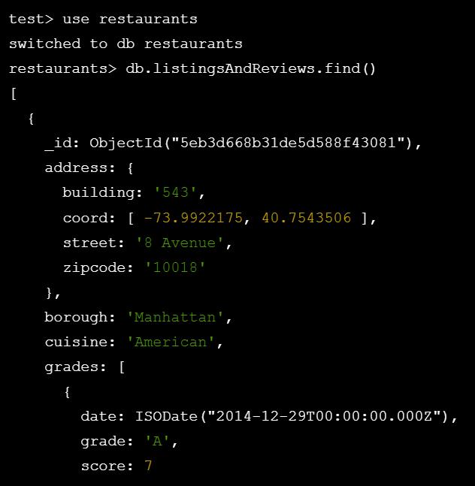

**Comparison Operators: $gt and $lt**

In the previous exercise, we briefly learned about MongoDB’s implicit equality operator $eq. MongoDB provides us with many more [comparison query operators](https://www.mongodb.com/docs/manual/reference/operator/query/?utm_campaign=academia_partners&utm_source=codecademy&utm_medium=referral#comparison) that we can use to match documents based on other measures of equality. In this exercise, we’ll learn how to match documents that are greater than or less than a specified value.

The greater than operator, [$gt](https://www.mongodb.com/docs/manual/reference/operator/query/gt/?utm_campaign=academia_partners&utm_source=codecademy&utm_medium=referral), is used in queries to match documents where the value for a particular field is greater than a specified value. Let’s have a look at the syntax for the $gt operator:

db.<collection>.find( { <field>: { $gt: <value> } } )

To see the $gt operator in action, consider the following collection of US National Parks:

{  
 name: "Yosemite National Park",  
 state: "California",  
 founded: 1890  
},  
{  
 name: Crater Lake National Park,  
 state: "Oregon",  
 founded: 1902  
},  
{  
 name: "Mesa Verde National Park",  
 state: "Colorado",  
 founded: 1906  
},  
{  
 name: "Olympic National Park",  
 state: "Washington",  
 founded: 1909  
},  
…

To find all parks that were founded after the year 1900, we could execute the following query:

db.national_parks.find({ founded: { $gt: 1900 }});

This would return documents where founded is 1901 or greater:

{  
 name: Crater Lake National Park,  
 state: "Oregon",  
 founded: 1902  
},  
{  
 name: "Mesa Verde National Park",  
 state: "Colorado",  
 founded: 1906  
},  
{  
 name: "Olympic National Park",  
 state: "Washington",  
 founded: 1909  
}

*Note: If we wanted to include the year 1900 in our query, we could use the* [*$gte*](https://www.mongodb.com/docs/manual/reference/operator/query/gte/?utm_campaign=academia_partners&utm_source=codecademy&utm_medium=referral)*, which will match all values that are greater than* or equal to *the specified value.*

We can also match documents that are less than a given value, by using the less than operator, [$lt](https://www.mongodb.com/docs/manual/reference/operator/query/lt/). For example, if we reference our national_parks example above, we could select all parks that were founded before 1900 with the following query:

db.national_parks.find({ founded: { $lt: 1900 }});

This would return all documents where founded is 1899 or lower.

{  
 name: "Yosemite National Park",  
 state: "California",  
 founded: 1890  
}

*Note: Similar to the $gte operator, we can use* [*$lte*](https://www.mongodb.com/docs/manual/reference/operator/query/lte/) *if we want to match all values that are less than* or equal to *the specified value.*

While the examples we examined in this exercise match numerical values, it’s worth noting that these comparison operators can be used with any data type (e.g., letters).

Let’s practice using these operators to query our listingsAndReviews collection!

### Instructions

**1.**

Connect to the restaurants database, then query the listingsAndReviews collection to retrieve a list of restaurants where the restaurant_id is greater than "50000000".

Checkpoint 2 Passed

Hint

You can use the .find() method with the $gt operator to find all the restaurants whose restaurant_id is greater than "50000000". Remember to use the following syntax:

db.<collection>.find({ <field>: { $gt: <value> } })

Hint

The street field is an embedded document inside of the address field. You can query the embedded field using the .find() method with the $lte operator like so:

db.<collection>.find({"<parent_field>.<embedded_field>": { $lte: <value> }})

**mongosh**



